[1.5,0.5,1]

1 run......

training 1 epoch...

521.9178738594055 seconds used......

1 training finished! average train loss: 0.40307637665706175

evaluating...

Confusion matrix, without normalization

[[ 161 107 26]

[ 190 3532 99]

[ 19 33 790]]

Normalized confusion matrix

[[0.54761905 0.36394558 0.08843537]

[0.0497252 0.92436535 0.02590945]

[0.02256532 0.0391924 0.93824228]]

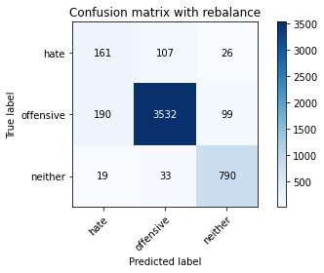

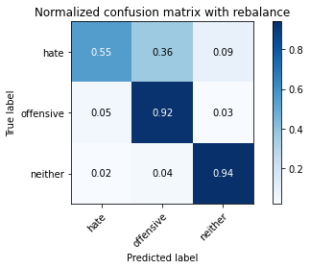

precision recall f1-score support

hate 0.44 0.55 0.48 294

offensive 0.96 0.92 0.94 3821

neither 0.86 0.94 0.90 842

accuracy 0.90 4957

macro avg 0.75 0.80 0.78 4957

weighted avg 0.91 0.90 0.91 4957

average eval_loss: 0.3404239866912605, accuracy: 0.9043776477708292

training 2 epoch...

522.2621374130249 seconds used......

2 training finished! average train loss: 0.2876420880145874

evaluating...

Confusion matrix, without normalization

[[ 196 82 16]

[ 296 3439 86]

[ 32 38 772]]

Normalized confusion matrix

[[0.66666667 0.27891156 0.05442177]

[0.07746663 0.90002617 0.0225072 ]

[0.03800475 0.04513064 0.91686461]]

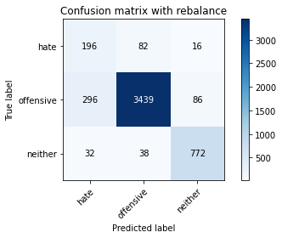

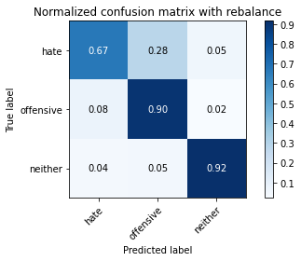

precision recall f1-score support

hate 0.37 0.67 0.48 294

offensive 0.97 0.90 0.93 3821

neither 0.88 0.92 0.90 842

accuracy 0.89 4957

macro avg 0.74 0.83 0.77 4957

weighted avg 0.92 0.89 0.90 4957

average eval_loss: 0.34907494414778006, accuracy: 0.8890457938269114

training 3 epoch...

522.380964756012 seconds used......

3 training finished! average train loss: 0.19965136552467988

evaluating...

Confusion matrix, without normalization

[[ 163 109 22]

[ 196 3533 92]

[ 23 39 780]]

Normalized confusion matrix

[[0.55442177 0.3707483 0.07482993]

[0.05129547 0.92462706 0.02407747]

[0.02731591 0.04631829 0.9263658 ]]

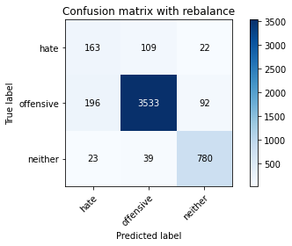

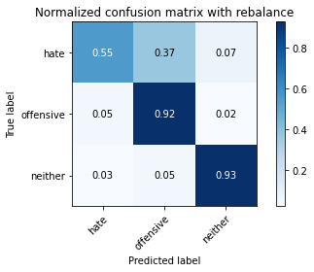

precision recall f1-score support

hate 0.43 0.55 0.48 294

offensive 0.96 0.92 0.94 3821

neither 0.87 0.93 0.90 842

accuracy 0.90 4957

macro avg 0.75 0.80 0.77 4957

weighted avg 0.91 0.90 0.91 4957

average eval_loss: 0.35991138038450793, accuracy: 0.9029655033286262

training 4 epoch...

522.5525326728821 seconds used......

4 training finished! average train loss: 0.11729776283168429

evaluating...

Confusion matrix, without normalization

[[ 150 128 16]

[ 200 3540 81]

[ 18 58 766]]

Normalized confusion matrix

[[0.51020408 0.43537415 0.05442177]

[0.05234232 0.92645904 0.02119864]

[0.02137767 0.06888361 0.90973872]]

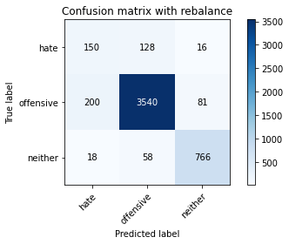

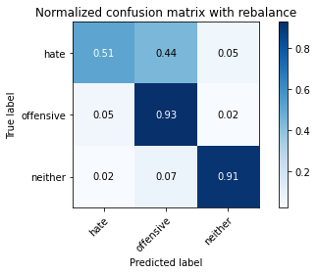

precision recall f1-score support

hate 0.41 0.51 0.45 294

offensive 0.95 0.93 0.94 3821

neither 0.89 0.91 0.90 842

accuracy 0.90 4957

macro avg 0.75 0.78 0.76 4957

weighted avg 0.91 0.90 0.90 4957

average eval_loss: 0.46166909849853255, accuracy: 0.898930804922332

training 5 epoch...

522.8295524120331 seconds used......

5 training finished! average train loss: 0.05916538871743767

evaluating...

Confusion matrix, without normalization

[[ 135 141 18]

[ 158 3579 84]

[ 13 61 768]]

Normalized confusion matrix

[[0.45918367 0.47959184 0.06122449]

[0.04135043 0.93666579 0.02198377]

[0.01543943 0.07244656 0.91211401]]

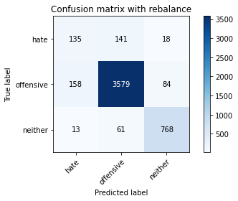

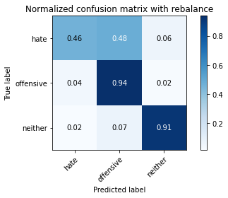

precision recall f1-score support

hate 0.44 0.46 0.45 294

offensive 0.95 0.94 0.94 3821

neither 0.88 0.91 0.90 842

accuracy 0.90 4957

macro avg 0.76 0.77 0.76 4957

weighted avg 0.91 0.90 0.90 4957

average eval_loss: 0.5829947892682779, accuracy: 0.9041759128505145

2 run......

2 run......

Downloading: 100%

411/411 [00:00<00:00, 15.2kB/s]

Downloading: 100%

263M/263M [00:12<00:00, 23.7MB/s]

training 1 epoch...

511.12446546554565 seconds used......

1 training finished! average train loss: 0.4063112902297308

evaluating...

Confusion matrix, without normalization

[[ 185 86 23]

[ 293 3433 95]

[ 24 26 792]]

Normalized confusion matrix

[[0.6292517 0.29251701 0.07823129]

[0.0766815 0.8984559 0.0248626 ]

[0.02850356 0.03087886 0.94061758]]

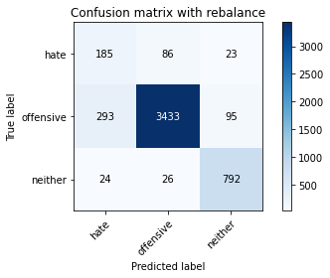

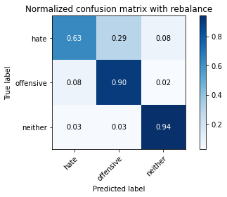

precision recall f1-score support

hate 0.37 0.63 0.46 294

offensive 0.97 0.90 0.93 3821

neither 0.87 0.94 0.90 842

accuracy 0.89 4957

macro avg 0.74 0.82 0.77 4957

weighted avg 0.92 0.89 0.90 4957

average eval_loss: 0.3690198181317218, accuracy: 0.8896509985878556

training 2 epoch...

510.8563063144684 seconds used......

2 training finished! average train loss: 0.2873846655749085

evaluating...

Confusion matrix, without normalization

[[ 157 117 20]

[ 141 3585 95]

[ 19 41 782]]

Normalized confusion matrix

[[0.53401361 0.39795918 0.06802721]

[0.03690133 0.93823606 0.0248626 ]

[0.02256532 0.04869359 0.92874109]]

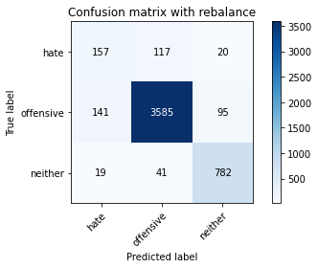

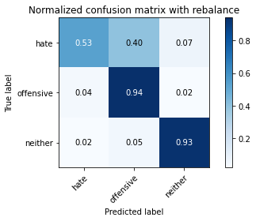

precision recall f1-score support

hate 0.50 0.53 0.51 294

offensive 0.96 0.94 0.95 3821

neither 0.87 0.93 0.90 842

accuracy 0.91 4957

macro avg 0.77 0.80 0.79 4957

weighted avg 0.92 0.91 0.91 4957

average eval_loss: 0.3443864885522353, accuracy: 0.9126487795037321

training 3 epoch...

510.7390615940094 seconds used......

3 training finished! average train loss: 0.19864249426022834

evaluating...

Confusion matrix, without normalization

[[ 175 107 12]

[ 310 3441 70]

[ 38 57 747]]

Normalized confusion matrix

[[0.5952381 0.36394558 0.04081633]

[0.08113059 0.90054959 0.01831981]

[0.04513064 0.06769596 0.8871734 ]]

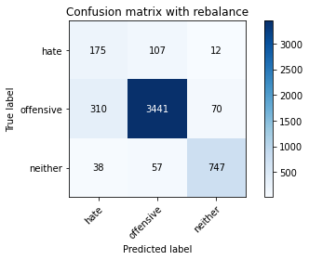

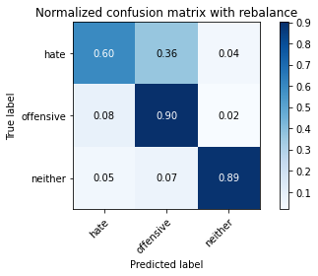

precision recall f1-score support

hate 0.33 0.60 0.43 294

offensive 0.95 0.90 0.93 3821

neither 0.90 0.89 0.89 842

accuracy 0.88 4957

macro avg 0.73 0.79 0.75 4957

weighted avg 0.91 0.88 0.89 4957

average eval_loss: 0.379828046451533, accuracy: 0.8801694573330644

training 4 epoch...

3 run......

Downloading: 100%

411/411 [00:00<00:00, 11.3kB/s]

Downloading: 100%

263M/263M [00:09<00:00, 30.6MB/s]

training 1 epoch...

512.0754108428955 seconds used......

1 training finished! average train loss: 0.40807905151779134

evaluating...

Confusion matrix, without normalization

[[ 142 130 22]

[ 152 3577 92]

[ 20 37 785]]

Normalized confusion matrix

[[0.4829932 0.44217687 0.07482993]

[0.03978016 0.93614237 0.02407747]

[0.02375297 0.04394299 0.93230404]]

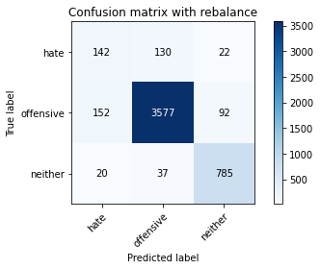

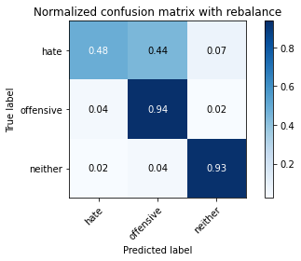

precision recall f1-score support

hate 0.45 0.48 0.47 294

offensive 0.96 0.94 0.95 3821

neither 0.87 0.93 0.90 842

accuracy 0.91 4957

macro avg 0.76 0.78 0.77 4957

weighted avg 0.91 0.91 0.91 4957

average eval_loss: 0.35461754279751934, accuracy: 0.908614081097438

training 2 epoch...

510.7074854373932 seconds used......

2 training finished! average train loss: 0.28506797256188526

evaluating...

Confusion matrix, without normalization

[[ 141 131 22]

[ 138 3597 86]

[ 14 61 767]]

Normalized confusion matrix

[[0.47959184 0.44557823 0.07482993]

[0.0361162 0.9413766 0.0225072 ]

[0.01662708 0.07244656 0.91092637]]

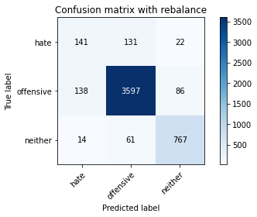

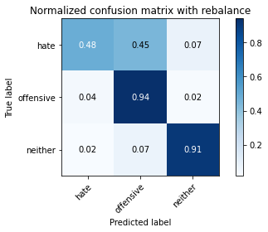

precision recall f1-score support

hate 0.48 0.48 0.48 294

offensive 0.95 0.94 0.95 3821

neither 0.88 0.91 0.89 842

accuracy 0.91 4957

macro avg 0.77 0.78 0.77 4957

weighted avg 0.91 0.91 0.91 4957

average eval_loss: 0.36283985312817796, accuracy: 0.9088158160177526

training 3 epoch...

510.9379184246063 seconds used......

3 training finished! average train loss: 0.19466921606808976

evaluating...

Confusion matrix, without normalization

[[ 141 137 16]

[ 132 3604 85]

[ 18 64 760]]

Normalized confusion matrix

[[0.47959184 0.46598639 0.05442177]

[0.03454593 0.94320858 0.02224549]

[0.02137767 0.0760095 0.90261283]]

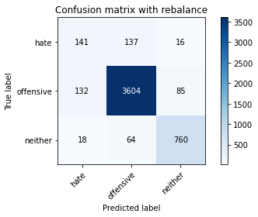

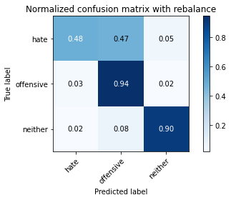

precision recall f1-score support

hate 0.48 0.48 0.48 294

offensive 0.95 0.94 0.95 3821

neither 0.88 0.90 0.89 842

accuracy 0.91 4957

macro avg 0.77 0.78 0.77 4957

weighted avg 0.91 0.91 0.91 4957

average eval_loss: 0.4175801093675076, accuracy: 0.9088158160177526

training 4 epoch...

511.18621349334717 seconds used......

4 training finished! average train loss: 0.1208576247480514

evaluating...

Confusion matrix, without normalization

[[ 161 117 16]

[ 216 3521 84]

[ 19 60 763]]

Normalized confusion matrix

[[0.54761905 0.39795918 0.05442177]

[0.0565297 0.92148652 0.02198377]

[0.02256532 0.07125891 0.90617577]]

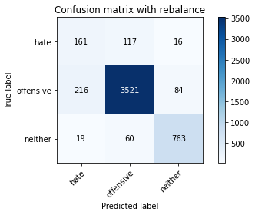

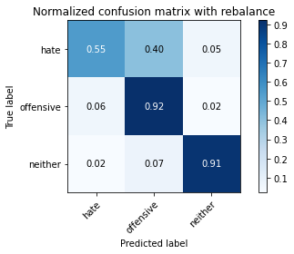

precision recall f1-score support

hate 0.41 0.55 0.47 294

offensive 0.95 0.92 0.94 3821

neither 0.88 0.91 0.90 842

accuracy 0.90 4957

macro avg 0.75 0.79 0.77 4957

weighted avg 0.91 0.90 0.90 4957

average eval_loss: 0.4636718744962221, accuracy: 0.8967117207988703

training 5 epoch...

511.20557832717896 seconds used......

5 training finished! average train loss: 0.06745547743289095

evaluating...

Confusion matrix, without normalization

[[ 143 131 20]

[ 187 3543 91]

[ 23 65 754]]

Normalized confusion matrix

[[0.48639456 0.44557823 0.06802721]

[0.04894007 0.92724418 0.02381576]

[0.02731591 0.07719715 0.89548694]]

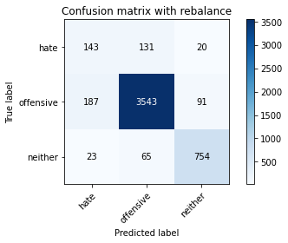

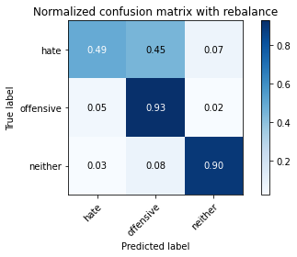

precision recall f1-score support

hate 0.41 0.49 0.44 294

offensive 0.95 0.93 0.94 3821

neither 0.87 0.90 0.88 842

accuracy 0.90 4957

macro avg 0.74 0.77 0.75 4957

weighted avg 0.90 0.90 0.90 4957

average eval_loss: 0.6219144500708705, accuracy: 0.8957030461972968

4 run......

training 1 epoch...

511.09519481658936 seconds used......

1 training finished! average train loss: 0.40311072413779553

evaluating...

Confusion matrix, without normalization

[[ 130 138 26]

[ 119 3604 98]

[ 9 52 781]]

Normalized confusion matrix

[[0.44217687 0.46938776 0.08843537]

[0.03114368 0.94320858 0.02564774]

[0.01068884 0.06175772 0.92755344]]

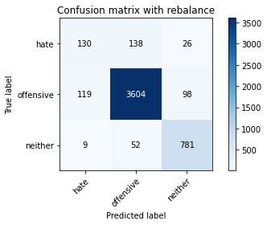

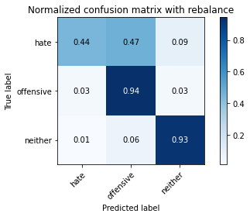

precision recall f1-score support

hate 0.50 0.44 0.47 294

offensive 0.95 0.94 0.95 3821

neither 0.86 0.93 0.89 842

accuracy 0.91 4957

macro avg 0.77 0.77 0.77 4957

weighted avg 0.91 0.91 0.91 4957

average eval_loss: 0.3423292190737782, accuracy: 0.9108331652208997

training 2 epoch...

511.12740302085876 seconds used......

2 training finished! average train loss: 0.2878131975603831

evaluating...

Confusion matrix, without normalization

[[ 161 113 20]

[ 169 3560 92]

[ 22 37 783]]

Normalized confusion matrix

[[0.54761905 0.38435374 0.06802721]

[0.04422926 0.93169327 0.02407747]

[0.02612827 0.04394299 0.92992874]]

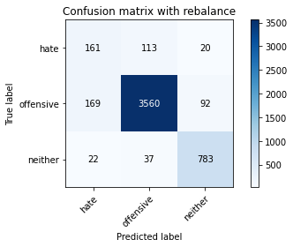

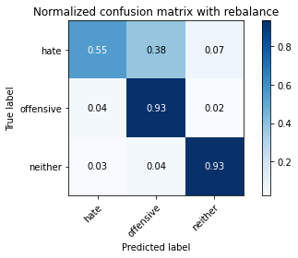

precision recall f1-score support

hate 0.46 0.55 0.50 294

offensive 0.96 0.93 0.95 3821

neither 0.87 0.93 0.90 842

accuracy 0.91 4957

macro avg 0.76 0.80 0.78 4957

weighted avg 0.92 0.91 0.91 4957

average eval_loss: 0.33726130884080646, accuracy: 0.908614081097438

training 3 epoch...

511.2950940132141 seconds used......

3 training finished! average train loss: 0.20149870156714197

evaluating...

Confusion matrix, without normalization

[[ 137 130 27]

[ 143 3563 115]

[ 11 49 782]]

Normalized confusion matrix

[[0.46598639 0.44217687 0.09183673]

[0.03742476 0.93247841 0.03009683]

[0.01306413 0.05819477 0.92874109]]

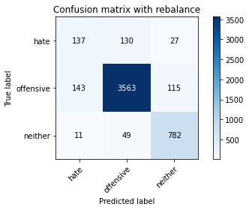

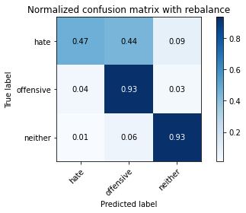

precision recall f1-score support

hate 0.47 0.47 0.47 294

offensive 0.95 0.93 0.94 3821

neither 0.85 0.93 0.89 842

accuracy 0.90 4957

macro avg 0.76 0.78 0.77 4957

weighted avg 0.91 0.90 0.90 4957

average eval_loss: 0.37831157485244704, accuracy: 0.9041759128505145

training 4 epoch...

511.39673471450806 seconds used......

4 training finished! average train loss: 0.12177249948417151

evaluating...

Confusion matrix, without normalization

[[ 139 134 21]

[ 167 3558 96]

[ 21 47 774]]

Normalized confusion matrix

[[0.47278912 0.45578231 0.07142857]

[0.04370584 0.93116985 0.02512431]

[0.02494062 0.05581948 0.9192399 ]]

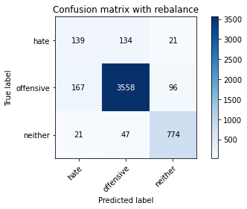

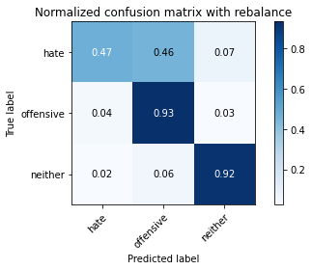

precision recall f1-score support

hate 0.43 0.47 0.45 294

offensive 0.95 0.93 0.94 3821

neither 0.87 0.92 0.89 842

accuracy 0.90 4957

macro avg 0.75 0.77 0.76 4957

weighted avg 0.91 0.90 0.90 4957

average eval_loss: 0.44145992116752875, accuracy: 0.9019568287270526

training 5 epoch...

511.59928798675537 seconds used......

5 training finished! average train loss: 0.06177214155703099

evaluating...

Confusion matrix, without normalization

[[ 114 161 19]

[ 108 3636 77]

[ 12 68 762]]

Normalized confusion matrix

[[0.3877551 0.54761905 0.06462585]

[0.02826485 0.95158336 0.02015179]

[0.01425178 0.0807601 0.90498812]]

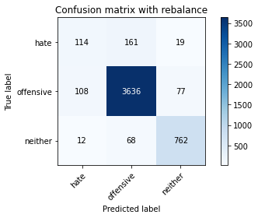

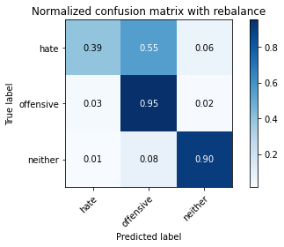

precision recall f1-score support

hate 0.49 0.39 0.43 294

offensive 0.94 0.95 0.95 3821

neither 0.89 0.90 0.90 842

accuracy 0.91 4957

macro avg 0.77 0.75 0.76 4957

weighted avg 0.90 0.91 0.91 4957

average eval_loss: 0.6382214816334336, accuracy: 0.9102279604599556

5 run......

training 1 epoch...

511.4442882537842 seconds used......

1 training finished! average train loss: 0.4024420137321877

evaluating...

Confusion matrix, without normalization

[[ 179 98 17]

[ 227 3518 76]

[ 18 55 769]]

Normalized confusion matrix

[[0.60884354 0.33333333 0.05782313]

[0.05940853 0.92070139 0.01989008]

[0.02137767 0.06532067 0.91330166]]

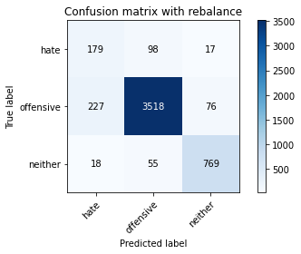

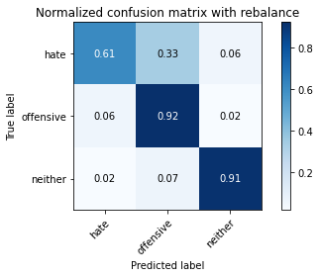

precision recall f1-score support

hate 0.42 0.61 0.50 294

offensive 0.96 0.92 0.94 3821

neither 0.89 0.91 0.90 842

accuracy 0.90 4957

macro avg 0.76 0.81 0.78 4957

weighted avg 0.92 0.90 0.91 4957

average eval_loss: 0.34916215795542926, accuracy: 0.9009481541254791

training 2 epoch...

511.4578423500061 seconds used......

2 training finished! average train loss: 0.284738265017363

evaluating...

Confusion matrix, without normalization

[[ 162 111 21]

[ 179 3552 90]

[ 21 43 778]]

Normalized confusion matrix

[[0.55102041 0.37755102 0.07142857]

[0.04684638 0.92959958 0.02355404]

[0.02494062 0.05106888 0.9239905 ]]

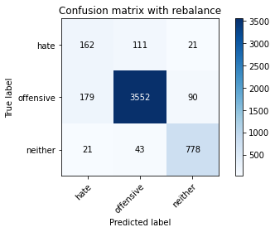

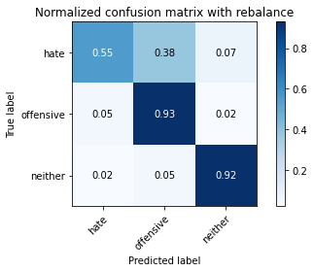

precision recall f1-score support

hate 0.45 0.55 0.49 294

offensive 0.96 0.93 0.94 3821

neither 0.88 0.92 0.90 842

accuracy 0.91 4957

macro avg 0.76 0.80 0.78 4957

weighted avg 0.91 0.91 0.91 4957

average eval_loss: 0.34736784683134886, accuracy: 0.9061932620536615

training 3 epoch...

511.4637145996094 seconds used......

3 training finished! average train loss: 0.19446144528610015

evaluating...

Confusion matrix, without normalization

[[ 132 147 15]

[ 108 3642 71]

[ 17 75 750]]

Normalized confusion matrix

[[0.44897959 0.5 0.05102041]

[0.02826485 0.95315362 0.01858152]

[0.02019002 0.08907363 0.89073634]]

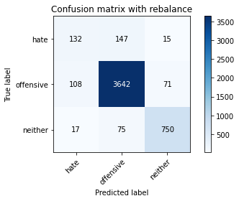

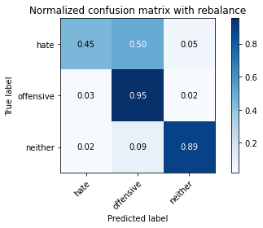

precision recall f1-score support

hate 0.51 0.45 0.48 294

offensive 0.94 0.95 0.95 3821

neither 0.90 0.89 0.89 842

accuracy 0.91 4957

macro avg 0.78 0.76 0.77 4957

weighted avg 0.91 0.91 0.91 4957

average eval_loss: 0.42578595830315363, accuracy: 0.9126487795037321

training 4 epoch...

511.7262303829193 seconds used......

4 training finished! average train loss: 0.10694676479643901

evaluating...

Confusion matrix, without normalization

[[ 142 129 23]

[ 201 3529 91]

[ 12 58 772]]

Normalized confusion matrix

[[0.4829932 0.43877551 0.07823129]

[0.05260403 0.92358021 0.02381576]

[0.01425178 0.06888361 0.91686461]]

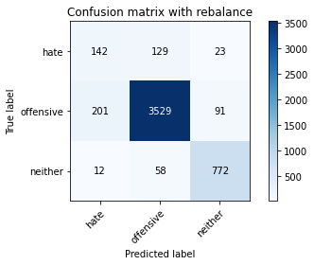

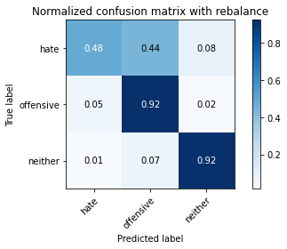

precision recall f1-score support

hate 0.40 0.48 0.44 294

offensive 0.95 0.92 0.94 3821

neither 0.87 0.92 0.89 842

accuracy 0.90 4957

macro avg 0.74 0.77 0.76 4957

weighted avg 0.90 0.90 0.90 4957

average eval_loss: 0.5205159422095618, accuracy: 0.8963082509582408

training 5 epoch...

511.58438992500305 seconds used......

5 training finished! average train loss: 0.05697063410788096

evaluating...

Confusion matrix, without normalization

[[ 125 152 17]

[ 153 3582 86]

[ 14 66 762]]

Normalized confusion matrix

[[0.42517007 0.5170068 0.05782313]

[0.04004187 0.93745093 0.0225072 ]

[0.01662708 0.0783848 0.90498812]]

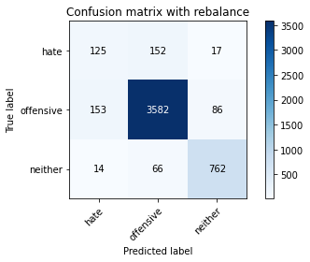

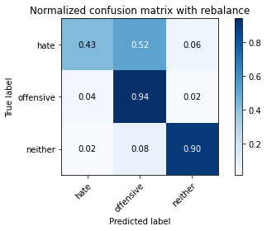

precision recall f1-score support

hate 0.43 0.43 0.43 294

offensive 0.94 0.94 0.94 3821

neither 0.88 0.90 0.89 842

accuracy 0.90 4957

macro avg 0.75 0.76 0.75 4957

weighted avg 0.90 0.90 0.90 4957

average eval_loss: 0.6860575778412773, accuracy: 0.9015533588864233